- \Operation\Basic settings\Tube dimensions
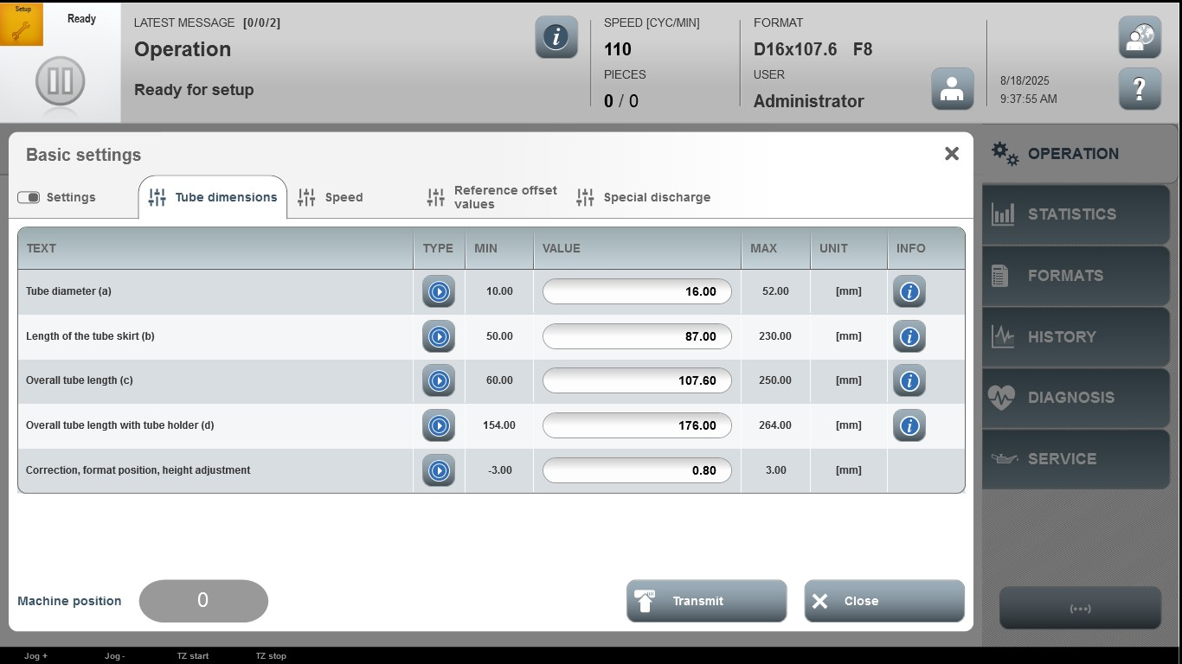

Acceptance criterion | Limits | Pass / Fail: Dev-No. | Date | Initials
Screen matches screenshot | N / A
Tube diameter (a) | 10.00…52.00
Length of the tube skirt (b) | 50.00…230.00
Overall tube length (c) | 60.00…250.00
Overall tube length with tube holder (d) | 154.00…264.00
Correction, format position, height adjustment | -3.00…3.00

